


Smart SHOPPING APP
System Requirements Specification v1.0

06.10.2026
Dongshin University
IT Team E

Table of Contents

1.0 Introduction 2
1.1 Purpose 2
1.2 Intended Audience and reading suggestions 2
1.3 Product Scope 3
1.4 Document Conventions 4
2.0 Overall Description 5
2.1 Product Perspective 5
2.2 Components 5
2.3 Identified Users of the system 5
3.0 Overall Process Diagram 6
3.3 PF1 Survey Management Proposed Workflow - Process Table 7
Appendix 9
Approval 10

Revision History
Date | Name | Reason for the Changes | Version
06.10.2026 | Harshika Randini | Initial Draft | 1.0

Introduction

The Smart Shopping App is a mobile application that helps customers shop easily and conveniently. It allows users to search for products, create shopping lists, manage selected items, calculate prices, monitor their budget, and make payments.

1.1 Purpose
The purpose of this system is to make shopping faster, easier, and more convenient by providing digital shopping-list management, automatic price calculation, budget monitoring, and online payment features.

1.2 Intended Audience and reading suggestions

This document is intended for customers, developers, supermarket staff, administrators, and project team members.

1. Customers

Customers will use the mobile application and smart shopping cart to purchase supermarket products.

2. Supermarket Staff

Staff members will monitor smart carts, assist customers, and handle cart or system problems.

3. System Administrators

Administrators will manage products, prices, inventory, discounts, users, and transactions.

4. Developers

Developers will use this document to understand the required system functions and develop the application.

5. Project Team

The project team will use the SRS to understand the project scope, workflow, system components, and requirements.

1.3 Product Scope

The application allows customers to:

* Search for products.

* View product prices and details.

* Create and manage shopping lists.

* Add or remove products from their shopping list.

* Calculate the total shopping price.

* Set and monitor their shopping budget.

* Receive product recommendations and offers.

* Make payments through the application.

* Receive digital receipts.

1.4 Document Conventions
The Document covers the conventions that are published by the IEEE. The template standards are published under “IEEE Standards Collection”.

2.0 Overall Description

2.1 Product Perspective

The application provides customers with a digital platform to search for products, create shopping lists, manage selected items, check prices, receive recommendations, and make payments.

2.2 Components of Document Management System
- Mobile application
- Product search system
- Shopping list system
- Backend server
- Database
- Recommendation system
- Payment system

2.3 Identified Users of the system
Customer: Searches for products, creates shopping lists, manages items, and makes purchases.
Administrator: Manages products, prices, discounts, and inventory.
Supermarket Staff: Updates product information and helps handle system-related problems

3.0 Overall Process Diagram
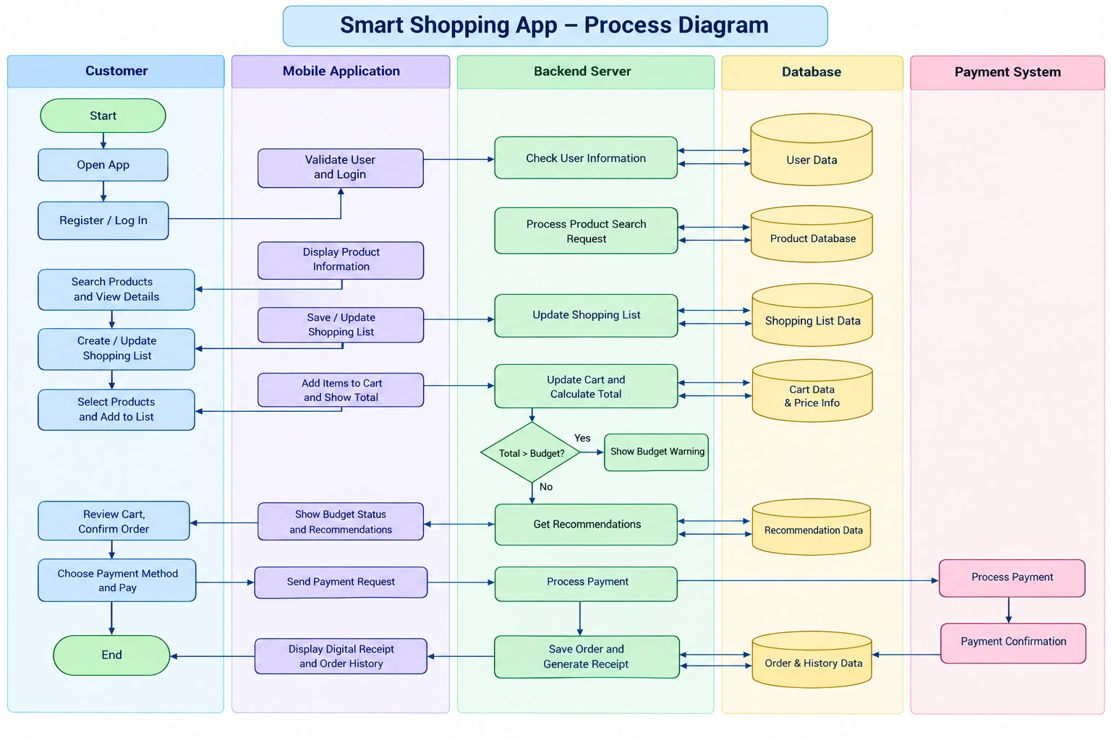

3.3 Smart Shopping App Proposed Workflow – Process Table
Process No | Process | Actor | Action | Pre- Condition | Post- Condition | Output
1 |  | Customer | User shall create an account or log in to the application. | User should have the app installed. |  | Home screen is displayed.
  User Registration / Login
  User is successfully logged in.
2 | Search Products | Customer | User shall search for products and view product information. | User should be logged in. | Product information is displayed. | Product name, price, and availability are shown.
3 | Create Shopping List | Customer | User shall add required products and quantities to the shopping list. | User should be logged in. | Shopping list is created. | Digital shopping list is displayed.
4 | Add Products | Customer |  | Products should be available. | Selected products are added. | Updated product list.
  User shall select products and add them to the shopping list or shopping basket in the app.
5 | Check Total and Budget | System / Customer |  | Products should be selected. | Total and budget status are displayed. | Total price and budget notification.
  System shall calculate the total price and compare it with the user's budget.
6 |  | System |  | User should have selected products. | Relevant recommendations are displayed. | Recommended products and offers.
  Product Recommendation
  System shall recommend related products, offers, or discounts.
7 | Confirm Order | Customer | Users shall review the selected products and confirm the order. | Products and total price should be available. | Order is confirmed. | Order confirmation.
8 | Payment |  | User shall select a payment method and complete the payment. | Order should be confirmed. | Payment is successfully completed. | Payment confirmation.
  Customer / Payment System
9 | Digital Receipt | System |  | Payment should be successful. | Order is saved in shopping history. | Digital receipt and order history.
  System shall generate and save the receipt after payment.

Appendix: Requirements Summary

Functional requirements:
- User registration and login
- Product search
- Shopping cart management
- Automatic price calculation
- Budget monitoring
- Digital payment
- Digital receipts
Non-functional requirements:
- Security
- Performance
- Reliability
- Usability
- Privacy

Approval of Smart Shopping App
We have read and understood the Software Requirements Specification (SRS), Version 1.0, for the Smart Shopping App.
We agree with the requirements and scope described in this document. Any future changes to the requirements will be discussed and approved by the project team.
.
Dongshin University    IT Group E  Signed by:  Name:  Designation:  Signature:  Date: | Smart Shopping App    Signed by:  Name:  Designation:  Signature:  Date:

